Document Analysis Organizer

Directions: As you analyze the primary source documents, complete the following graphic organizer.

Document | BIG ITEMS  What is the main idea of the document? | EFFECT  Does the document reveal a positive or negative effect of political machines? | EVIDENCE  Write quotations or key ideas from the document that supports your opinion.
‘Twas Him
“Why the Ward Boss Rules”
Mr. Richard Crocker and Greater New York
The Shame of the Cities
Plunkitt of Tammany Hall
Machine Politics in Chicago

‘Twas Him
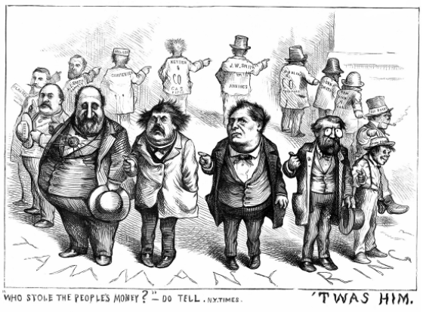
Thomas Nast, "Twas Him," Harper's Weekly, (August 19, 1871)

The caption reads "Who stole the peoples' money?" The large man at the left of the image represents Boss Tweed. He is joined by two members of Tammany Hall, the mayor, and various city contractors that the city did business with such as carpenters.

Why the Ward Boss Rules
The Alderman (city council member), therefore, bails out his constituents (residents of a district) when they are arrested, or says a good word to the police justice when they appear before him for trial; uses his "pull" with the [judge] when they are likely to be fined for a civil misdemeanor (small crime), or sees what he can do to "fix up matters" with the State’s attorney when the charge is really a serious one.

Because of simple friendliness, the Alderman is expected to pay rent for the hard-pressed tenant when no rent is forthcoming, to find jobs when work is hard to get, to procure (get) and divide among his constituents all the places he can seize from the City Hall. The Alderman of the Nineteenth Ward (district) at one time made the proud boast that he had two thousand six hundred people in his ward upon the public pay-roll. This, of course, included day-laborers, but each one felt under distinct obligations to him for getting the job.
Jane Addams, “Why the Ward Boss Rules” Outlook, volume 57 (April 2, 1898)
Mr. Richard Croker and Greater New York

We were silent for a time. Mr. Croker took a turn or two, and then resumed:

"People [blame] Tammany (Hall) for this and for that. But they forget what they owe to Tammany. There is no denying the service which Tammany has rendered (provided) to the Republic. There is no such organization for taking hold of the untrained friendless man and converting him into a citizen. Who else would do it if we did not? Think of the hundreds of thousands of foreigners dumped into our city. They are too old to go to school. There is not a [reformer] in the city who would shake hands with them…Except to their employer they have no value to anyone until they get a vote." "And then they are of value to Tammany?" I said, laughing. "Yes," said Mr. Croker, imperturbably (calmly); "and then they are of value to Tammany. And Tammany looks after them for the sake of their vote, grafts (joins) them upon the Republic, makes citizens of them in short; and although you may not like our motives or our methods, what other agency is there by which so long a row could have been hoed so quickly or so well? If we go down into the gutter it is because there are men in the gutter, and you have got to go down where they are if you are to do anything with them."

William T. Stead, “Mr. Richard Croker and Greater New York,” Review of Reviews, XVI (October, 1897)

The Shame of the Cities

Tammany leaders are usually the natural leaders of the people in these districts, and they are originally good-natured, kindly men. No one has a more sincere liking than I for some of those common but generous fellows; their charity is real, at first. But they sell out their own people. They do give them coal and help them in their private troubles, but, as they (Tammany leaders) grow rich and powerful, the kindness goes out of the charity (gifts) and they not only collect at their saloons or in rents cash for their "goodness"; they not only ruin fathers and sons and cause the troubles they relieve; they sacrifice the children in the schools; let the Health Department neglect the tenements and, worst of all, plant vice (immoral or evil practices) in the neighborhood and in the homes of the poor.
Lincoln Steffens, The Shame of the Cities, (1904.)

Plunkitt of Tammany Hall

If there's a fire in Ninth, Tenth, or Eleventh Avenue, for example, any hour of the day or night, I'm usually there with some of my election district captains as soon as the fire engines. If a family is burned out, I don't ask whether they are Republicans or Democrats, and I don't refer them to the Charity Organization Society, which would investigate their case in a month or two and decide they are worthy of help about the time they are dead from starvation. I just get quarters (places to live) for them, buy clothes for them if their clothes were burned up, and fix them up till they get things humming' again. It's philanthropy (caring for others), but its politics, too – mighty good politics. Who can tell how many votes one of these fires brings me? The poor are the most grateful people in the world, and, let me tell you, they have more friends in their neighborhoods than the rich have in theirs.

If there's a family in my district in want, I know it before the charitable societies do, and me and my men are first on the ground…The consequence is that the poor look up to George W. Plunkitt as a father, come to him in trouble - and don't forget him on election day.

Another thing, I can always get a job for a deservin' man. I make it a point to keep on the track of jobs, and it seldom happens that I don't have a few up my sleeve ready for use. I know every big employer in the district and in the whole city, for that matter, and they ain't in the habit of sayin' no to me when I ask them for a job.

George Washington Plunkitt, William L. Riordan, Plunkitt of Tammany Hall, (1905)

Machine Politics in Chicago

Crime conditions among the colored (African-American) people are being deliberately fostered by the present city administration…Disorderly cabarets (nightclubs), thieves, and depraved (evil) women are allowed in the section of the city [of Chicago] where colored people live. And, he added, the black people were being "exploited" (misused for personal gain) not just by whites but also for the sake of men in politics who are a disgrace to their own race.

The colored people have simply been sold out by the colored leaders. Our leaders are in the hands of white politicians, even though what the black people most need [are] representatives who are strictly representative, who are responsible first of all to the people of the ward.

Dr. George Cleveland Hall, William L Tuttle, Jr., Race Riot: Chicago in the Red Summer of 1919, (1970).

