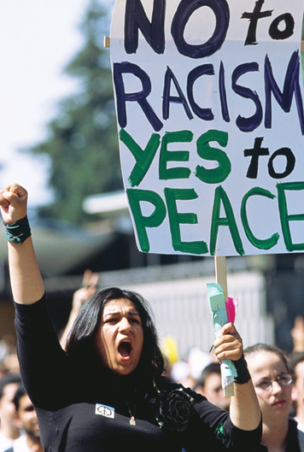
Safeguarding Equality
For many Americans, the 9/11 attacks brought to mind memories of the U.S. response to Japan’s attack on Pearl Harbor 60 years earlier. Following that assault, the government forced more than 100,000 Japanese Americans to live in internment camps. After learning that the 9/11 terrorists were Arab Muslims, many people of Middle Eastern descent worried that they might suffer a similar fate. Many felt afraid to go to work or school for fear of being singled out for attack, even if they were not Muslim.
In contrast to the events of 1941, Bush made an effort to reassure American Muslims that they would be treated the same way as other citizens. Days after the attacks, he met with Muslim leaders. “America counts millions of Muslims amongst our citizens,” he declared. “In our anger and emotion, Americans must treat each other with respect.”

Balancing Safety and Equality: The Profiling Debate:
The question of how best to protect the ideal of equality in the new, post-9/11 circumstances first arose in airports. Air travel resumed within a week of the attacks. Airport security officials began paying special attention to young men who looked like the 9/11 terrorists or had names similar to those of the terrorists. These travelers faced more rigorous searches than others did. Authorities even took some of them off planes “for security reasons.” The practice of using physical traits to decide whether to investigate or arrest someone is known as racial profiling.
To some Americans, racial profiling was clear discrimination. They felt that all passengers should go through the same search procedures. Norman Mineta, the U.S. secretary of transportation, agreed. As a child, he had been sent to an internment camp. After 9/11, Mineta banned racial profiling in airports. He explained, “Surrendering to actions of hate and discrimination makes us no different than the despicable terrorists who rained such hatred on our people.”
Others strongly supported racial profiling. They viewed terrorism as an extreme threat that justified the use of special security procedures. To them, putting an elderly woman through the same security checks as a young man of Middle Eastern descent went against common sense. The principle of equality, they urged, should not be allowed to jeopardize public safety.
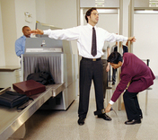
Despite the difference of opinions, racial profiling continues to be a fact of life in the United States—for Arab Americans and many others. By 2005, according to Amnesty International USA, 32 million Americans had reported experiencing racial profiling. Another 87 million, the organization claimed, had traits that put them at risk of being profiled in this way. They might face such treatment in many places other than airports—while shopping or looking for housing, for example. The federal and many of the state governments do ban forms of racial profiling. But there often are few provisions for how to enforce such bans or punish those who violate them.
In 2006, the International Association of Chiefs of Police addressed such concerns. With Justice Department support, it published a set of civil rights guidelines for police. The publication acknowledges the challenges a law enforcement agent faces when trying both to protect equality and to prevent crime. The aim of the guidelines is to assist officers in handling such situations.

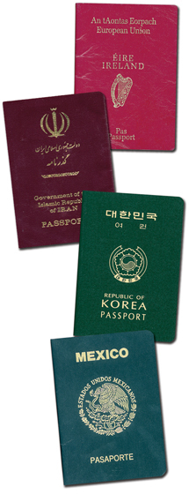
Preserving Opportunity
The United States has long appealed to immigrants as a land of opportunity. But after 9/11, the government put in place tougher immigration policies in an effort to keep terrorists out of the country. Some Americans felt that these policies reflected a growing fear of foreigners. The new laws did, in fact, make it harder for some foreign students, workers, and tourists to enter or stay in the country. The result has been a loss of opportunity for foreigners and for the schools and businesses that cater to them. Can the United States continue to be a land of opportunity while trying to close it borders to terrorists?

Balancing Security and Opportunity: Screening Foreign Visitors
Tens of millions of foreigners visit the United States each year. Some arrive as permanent immigrants, but the vast majority comes as short-term visitors. In 2001, foreigners except Canadians and Mexicans needed a passport and visa to enter the United States. A passport is a document issued by a person’s home government to verify his or her identity. A visa is an authorization from a government for a foreigner to enter its country. Before 9/11, foreigners could easily obtain visas for the United States through travel agents. The 9/11 terrorists all entered the country legally in 2001, with valid passports and visas.
After 9/11, Congress passed new laws to make the country’s borders more secure. Today all foreign visitors must show travel documents to enter the United States. Those from Canada and 36 selected countries now need only a passport. Others need a passport and a visa. The U.S. government added numerous new procedures to make visas harder to obtain. As part of the process, officials now check each applicant’s identity against a “watch list” of known or suspected terrorists. The restrictions on applicants from the Middle East are especially strict. Some people feel that the new security procedures violate visitors’ privacy. Others see them as a legitimate way of protecting the nation from terrorists.
The new visa requirements led to long delays for applicants. Many Americans complained that the delays were denying foreigners access to the opportunities that have been a hallmark of American life. Others worried about the impact of the new policies on American culture and economics. The Department of State, which issues visas, has worked to streamline the application process. But the careful screening of visitors continues in efforts to limit potential threats to national security.
The government has also sharpened its focus on foreigners who enter or live in the country illegally. Most are Mexicans looking for work in the United States, where they find better pay and more work options than in Mexico. Some entered the United States legally but have stayed beyond the terms of their visas. Others came into the country illegally. Many U.S. employers rely heavily on these workers and may overlook or not be aware of their workers’ illegal status.
Many Americans feel it is inappropriate and unsafe to allow anyone to be in the country illegally. Yet, as the government has increased its focus on border security, critics have pointed out that the motivations for illegal immigration—the need for work and workers—persist. The question of whether the flow of undocumented migrants can or should be stopped is a heated one.

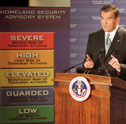
Securing Liberty
As the initial shock of 9/11 began to fade, many Americans remained fearful. A week later, Bush addressed their fears in a speech to the nation:
After all that has just passed . . . it is natural to wonder if America’s future is one of fear . . . But this country will define our times, not be defined by them. As long as the United States of America is determined and strong, this will not be an age of terror; this will be an age of liberty, here and across the world.

Balancing Safety and Freedom: The Department of Homeland Security

Bush’s words highlighted an immediate reaction that many Americans had to 9/11. Would the only way to stay safe in light of this new situation—the threat of warfare on U.S. soil—be to stay indoors, avoid speaking to anyone one did not know well, or restrict the activities of all Americans until the situation came under control? That is, would Americans have to give up their freedoms of movement and expression, among many others, to feel secure? The nation was on new ground. Many people felt unsure of how to navigate it. What most knew for certain was that they wanted their liberty secured in this time of terrorism.
Before 9/11, numerous government agencies shared the role of defending the nation. After the attacks, Bush called on Congress to centralize these functions by creating the Department of Homeland Security (DHS). DHS coordinates 22 security-related federal agencies that deal with issues including border control, disaster relief, and nuclear safety. Its mission is to “prevent and deter terrorist attacks and protect against and respond to threats and hazards to the nation.” To do this, it implemented the National Response Plan to deal with emergencies and set up a system to inform the public about terrorist threats. The system includes five threat levels, ranging from “low risk” to “severe risk.”
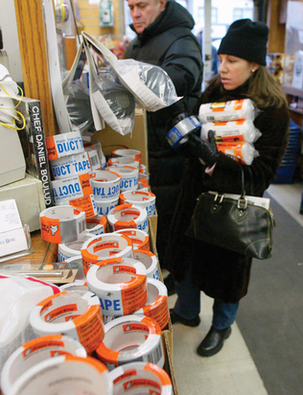
In 2002, Bush also set up a commission to investigate the circumstances surrounding the 9/11 attacks and suggest lessons to be learned. The commission published its findings in 2004 and made 37 recommendations to improve national security. For example, the nation’s infrastructure still needed a formal protection plan, airline passenger screening still needed improvement, and there needed to be government-wide sharing of information.
But considerations of how to bring about such improvements have raised further concerns. Congress determines the DHS budget, but some Americans have questioned whether party politics and financial concerns, rather than need, have shaped DHS policies. For example, Congress allocates DHS funds to each state. The amount to be spent on high-risk areas varies from state to state. However, DHS also distributes a fixed amount to all states, regardless of the state’s population. Politicians and citizens have debated this practice. Should funding increase with state population, or should all states receive equal funds? Are some cities at greater risk than others? Do they deserve more money?
Determining which areas of public life face the greatest threat of attack raises the questions of whether Americans have an active voice in who decides that and how. These questions highlight a challenge: how to balance the threat that terrorists pose to our liberty with the realities of the financial and political limitations under which any government agency operates.

Protecting Rights
After 9/11, the Bush administration asked Congress for new powers to fight terrorism. Just 45 days after the attacks, Congress passed a 342-page bill known as the USA Patriot Act. This act loosened many restrictions on intelligence gathering by U.S. security and law enforcement agencies. As details became public, Americans began debating the act’s impact on their constitutional rights.

Balancing Security/Privacy Rights: Debating the Patriot Act
The most controversial sections of the Patriot Act involve privacy rights protected by the Fourth Amendment. Originally written in response to the British practice of invading colonial homes to collect unpaid taxes, this amendment bans unreasonable searches and seizures by government officials. It defines as reasonable only searches and seizures that are authorized by a search warrant from a judge. To gain a warrant, agents must show probable cause, ie show that there is reason to believe a crime has already been committed.
Today the Fourth Amendment applies to both homes and communication devices. For example, federal agents cannot place wiretaps on telephones without a search warrant. Before the Patriot Act, a judge had to issue a separate warrant for each phone that agents wished to monitor. The act expanded the power of federal agencies to carry out such electronic surveillance. Judges may now approve a single warrant for tapping all phones a suspect uses. That means a wiretap can “rove” from phone to phone to follow a suspect’s communications.
Concerned Americans have opposed roving wiretaps, arguing that their use could easily violate the privacy rights of people who talk unknowingly to a suspected terrorist. But law enforcement officials contend that agents need roving wiretaps to track down terrorists who move from phone to phone.
The Patriot Act also allows agents with a warrant to search a suspect’s home or business in secret. Agents may break in, take photographs, examine computers, and remove evidence without alerting the suspect. Officials argue that this freedom allows them to carry out a lawful search without giving suspects a chance to flee or destroy evidence. Critics view the use of these “sneak and peek” warrants as a clear violation of privacy rights.
The Patriot Act also allows officials to seize and search computer records for data that might lead to terrorists. First, agents must make a case that they need the data “to protect against international terrorism.” But they do not have to show probable cause—only suspicion that a crime might occur. Critics view this as a step away from the Fourth Amendment’s intent. They worry about giving the government such access to electronic databases. And they complain that the Patriot Act gives judges little power to deny requests for such access.
In 2005, reporters discovered that Bush had allowed phone calls between Americans and suspected terrorists to be monitored without warrants. Critics viewed such warrantless surveillance as another violation of privacy rights. The Bush administration claimed that judges could not issue warrants quickly enough to support terrorism investigations. In 2007, the administration changed its stance on warrantless surveillance. It established a secret court geared at working quickly to approve all surveillance. But Americans continued to debate the question: To what degree is spying on civilians justified?

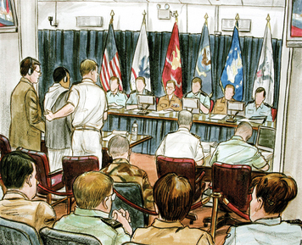
Defending Democracy
Soon after 9/11, President Bush raised a question: “Why do they hate us? They hate what they see right here in this chamber—a democratically elected government . . . They hate our freedoms—our freedom of religion, our freedom of speech, our freedom to vote and assemble and disagree with each other.”
Over the next five years, Americans both praised and criticized Bush’s policies in the war on terrorism. Some applauded his efforts to bring democracy to Iraq. Others denounced his treatment of prisoners captured in the war in Afghanistan.

Debating the Limits of Presidential Power: Military Commissions
During the 2001 invasion of Afghanistan, the U.S. military took many prisoners. After the fighting, most remained in Afghanistan. But Bush ordered that 660 prisoners from 42 nations be detained at a U.S. military base in Guantánamo Bay, Cuba. These detainees were described as unlawful enemy combatants, or fighters in armed conflict with the United States who were not part of a regular army. They were not accused of any crime, yet they were interrogated regularly. The government hoped they could provide information about anti-U.S. terrorists.
Bush’s critics argued that detainees should be treated as prisoners of war (POWs). Under the Geneva Conventions, POWs have certain rights. They may not be tortured or subjected to humiliating treatment. They may petition for a writ of habeas corpus—an order compelling a prison official to take a prisoner in front of a court to assess whether the person is imprisoned lawfully. Bush claimed that these rights did not apply to unlawful military combatants.
In June 2004, the Supreme Court ruled in Rasul v. Bush that the detainees did have the right to challenge their imprisonment in court. Bush responded by establishing military commissions to try detainees. These are courts set up by the armed forces to try enemy forces during wartime. Critics attacked Bush’s decision on several grounds. One was that detainees tried by the commissions lacked basic legal rights. For example, they might not be allowed to hear evidence against them if the court ruled that making such evidence public could damage national security. Critics also charged that Bush had gone beyond the limits of his power in setting up the military courts. In the U.S. democratic system, the power to establish courts belongs to Congress, not the president.
In June 2006, the Supreme Court agreed with the critics. In Hamdan v. Rumsfeld, the Court ruled that Bush did not have constitutional authority to set up military courts. In his written opinion, Justice Stephen Breyer noted that “the Court’s conclusion ultimately rests upon a single ground: Congress has not issued the Executive a ‘blank check’” to do whatever he wants. Breyer wrote that the president must still ask Congress for the authority he believed necessary. Further, Breyer stated that the Court’s insistence that the president consult with Congress did not undermine the nation’s ability to defend itself. “To the contrary,” Breyer wrote, “that insistence strengthens the Nation’s ability to determine—through democratic means—how best to do so. The Constitution places its faith in those democratic means. Our Court today simply does the same.”
After this ruling, Bush did consult with Congress on the treatment of detainees. In September 2006, Congress passed the Military Commissions Act of 2006. This act authorized the use of military commissions to try enemy combatants and set out rules for such trials. However, the act was widely condemned for failing to grant detainees basic legal rights, including habeas corpus. A New York Times editorial described the Military Commissions Act as “a tyrannical law that will be ranked with the low points in American democracy, our generation’s version of the Alien and Sedition Acts.” Clearly the debate over the treatment of illegal enemy combatants was far from over.

